What is software testing?

Identify the correctness of application. Software testing is the process of evaluating and verifying that a software product or application does, what it is supposed to do. The benefits of testing include

Types of testing?

Manual testing: Manual Testing is done manually by QA analyst (Human) whereas Automation Testing is done with the use of script, code and automation tools.

Automation testing

When we do automation testing.?

After manual testing is passed.

What it testing environment? It will be stable which ever the environment.

**What tools other than selenium for testing;**

Cucumber, UFT,sypress, testNG, katalon studio

**What are levels of testing ?**

--unit test which do developers

-- acceptance testing—done by both developers and tester

-- system testing—whole system testing done by developer and tester

-- integration testing – combining front end and back end , done both dev and tester.

A level of software testing is a process where every unit or component of a software or system is tested. The main reason for implementing the levels of testing is to make the software testing process efficient and easy to find all possible test cases at a specific level.

**Types of testing ?**

Functional testing; smoke test, regression testing

Non-functional testing ; performance testing, security testing, load testing

The difference between functional testing and non-functional testing is what they test. Functional testing ensures that the functions and features of the application work properly.

Non-functional testing examines other aspects of how well the application works. Functional testing tests the functionality of an app.

**What is selenium ?**

**Selenium is a set of tool which helps us test application mainly used to perform functional testing.**

Selenium is a free (open-source) automated testing framework used to validate web applications across different browsers and platforms.

This post provides a list of major differences between Functional Testing and Non-Functional Testing.

Definition

Functional Testing is a process to validate that each functionality of a software application is implemented according to the end-user or customer expectations conforming to the software specification document.

Non-Functional Testing ensures that the software application meets the specified performance requirements. It includes testing or readiness of several non-functional aspects of the application specific to performance, reliability, security etc.

Timing

Functional Testing will always be done prior to Non-Functional Testing to make sure that the application works according to the specifications.

Non-Functional Testing will be done once Functional Testing completes. It assumes that the application works according to the business and functional requirements, hence focuses on other aspects of the application.

Resources

Functional Testing can be performed manually. It is preferred to test the application manually before automating the manual test cases. Test automation has to be done based on application stability and the project budget.

Non-Functional Testing is difficult to perform manually. It always needs good tools and experienced resources to cover non-functional aspects of the application.

Testing Types

Types of Functional Testing includes Unit Testing, Smoke Testing, Integration Testing, Regression Testing, System Testing, User Acceptance Testing.

Types of Non-Functional Testing includes Volume testing, Load Testing, Stress Testing, Recovery Testing, Scalability Testing, Security Testing

Test Cases & Test Data Source

In Functional Testing, test cases and test data preparation always need the functional specification document.

In Non-Functional Testing, the performance requirements can be considered as the source to prepare test cases and test data.

Testing Tools

Testing tools used for Functional Testing includes UFT(Previously QTP), Selenium,

Rano-rex, Telerik Test Studio, Micro Focus, Sahi, Test Complete, IBM Rational.

Testing tools used for Non-Functional Testing includes JMeter, LoadRunner, WebLOAD, Neo-Load, Load-Complete.

Test Case Example

Functional Testing - Test whether the user is able to login to the application.

Non-Functional Testing - Time required to load the home page

There are four components of selenium?

**Selenium Components;**

* Selenium IDE.
* Selenium RC.
* Selenium WebDriver.
* Selenium Grid

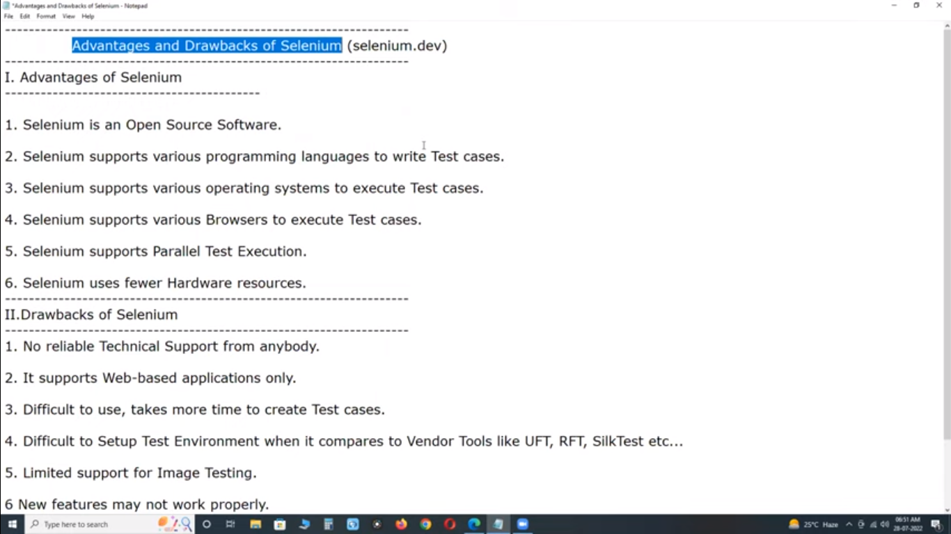

Selenium IDE- integrated development environment

Selenium Grid- fire-fox plugin

Selenium wed Driver

Selenium RC- remote control

**What is selenium ?**

Selenium is open-source automation tool which is used to automate the web application.

**Web driver is an interface.**

Advantages and disadvantages of selenium web driver.

Advantage; open source free to install, download and use.

2. work with different languages, ruby, c sharp, python, java script, java.

3. it support multiple browser (chrome, fire fox, edge, opera, safari, internet explorer), support cross browser testing

4, you can use it with window, mac, Linux. Os independent.

Go to selenium website to check its details.

Disadvantages;

1. Not technical support. Because it is free.
2. It is only support webpage application it does not automate desktop application.
3. Can not test capchas, images, videos.

Create more time to create test cases.

Get current url , why I need the url?

url is needed to check the that the url is correct after navigate to the page.

2. to get the title on the tab of page.

**There are two methods to get navigate**

1. Get method
2. Navigate method

**What is difference between them.**

Get method don not have history of page

Get method wait to overload the page completely

Navigate do not wait to load fully the page, it keeps history of page.

Navigate is used to move forward and backward, and you can also refresh the page.

Navigate().back(); method is used to move back.

Navigate().forward(); method is used to forward the tab.

Navigate().refresh(); this is used to refresh / reload the page.

**What is difference in close (); and quit(); method.**

Quit method terminate all the tabs running.

Close method close only one tab.

drive.manage().window().maximize(); *// this is the method to maximize windwo.*drive.manage().window().fullscreen(); *// this is method for full screen./ occupy the whole screen, you don’t see url box.*

Methods in first video, first learn .

To get

To navigate to forward, to back , to refresh, to thread, sleep.

To close

To quit

To manage window maximize

To manage window full screen

To get url

To get title

First set property

Then create object of your browser

Then navigate to Facebook , YouTube , URL

After that maximize your window.

---------------------------------------------------------------------------------------------------

CLASS 02

**What is web elements ???**

Any thing you see on web page is called web element   
  
In Selenium, **Web Element** is an interface representing an HTML element on a web page. It provides methods to interact with and manipulate various elements on a web page such as buttons, input fields, checkboxes, dropdowns, etc.

HTML,html stands for what**; The HyperText Markup Language or HTML is the standard markup language for documents designed to be displayed in a web browser..**

Extensible Markup Language (XML)

DOM; document object model. It is internal view of webpage. It is also called developer’s tool.

Each and every line in HTML is called object

The purpose of HTML is to structure and organize content on a webpage, while CSS is used to style and visually enhance the presentation appearance of that content. By combining HTML and CSS, web developers can create visually appealing and well-structured web pages that are easy to read, navigate, and interact with.

Use of locator to find element.

Fine element method

By locator name

Send keys method

Click method.

---------------------------------------------------------------------

What is locator ??

Locator is the address or position of web element on the web page.

---------------------------------------------------------------------------------------

Why we do need locators in selenium???????????

We need locator to locate or identify web elements on web pages.

-----------------------------------------------------------------------------------------

An attribute and values, in the context of web development and HTML, refers to additional information provided within the tags of an HTML element that helps define its characteristics or behavior.

Attributes and values are key-value pairs added to HTML elements to provide additional information or to modify the behavior of the element.

For example, in the HTML element **<img src="example.jpg" alt="Example Image">**, **src** and **alt** are attributes. In this case:

* **src** attribute specifies the source URL of the image.
* **alt** attribute provides alternative text for the image, which is displayed if the image cannot be loaded or for accessibility purposes.

----------------------------------------------------------------------------------------------

Link text locator is used when the html has “<a” tag and it should have text. It should have a link where it will take to you .And text will be between opening angle and closing angle >forgotten password<

There are 8 eight locators;

1. Id

If id locator has number then it is not secure it can be change when the websites will updated. If id has number then you should use other locator.

(<a id="ctl00_logout" href="javascript:__doPostBack('ctl00$logout','')">Logout</a>)

1. Name
2. Tag name
3. link text
4. partial link text
5. xpath
6. css selector (Cascading Style Sheets What is CSS? Cascading Style Sheets (CSS) is a simple mechanism for adding style (e.g., fonts, colors, spacing) to Web documents. These pages contain information on how to learn and use CSS and on available software. )
7. class

this is website of first task.

<http://secure.smartbearsoftware.com/samples/TestComplete11/WebOrders/Login.aspx>

<https://parabank.parasoft.com/parabank/initializeDB.htm;jsessionid=9A28DB5938014C79992791607865D2D0>

1. why we have so many locators in selenium?

Because some locators might have duplicate values/attribute values on ther nodes.

1. Who provide us the locators? Developers, they can not provide locator for every web element we have to find best locator of that web element form specified locator.
2. Some locators are not applicable for the elements we are looking for.

Link text and partial link text are used only for link web elements.

“a” tag is also called anchor tag it is used for link web elements.

--------------------------------------------------------------------------------------------------------------------------------------------------------------------------------------------------------------------------------------------------------------------------------------

What is x-path and css selector? Why we do need x and css path??

With x and cc path we can locate the element by any given attribute.

X-path is query language (is a language to identify and finding elements on web page.) it help us to identify elements uniquely on the web page.

**Types of x-path?**

**1. absolute x-path?** It starts from starting node html. It is not used so much. It always start with single (/). Control+F shortcut to search box on dom. We will not use absolute x path because it is risky.

Why we don’t use absolute x path? because it is very long to locate the locator. I

1. If developers update the website and add on more div between two then your absolute path will be get error.

**2. Relative x path?** Starts from any node in html starts from //

? Is mostly used locator after th ID locator.

When you want to go on second div then you use index

/html/body/div[2] it starts from one in x path. But arrays starts with zero.

//input[@id='email']

//a[text()='Create new account']

How find element by x path

First of all you have to write a query language in DOM to find elements by x path.

//a[text()='Create new account'] // we did not use @ sign because text is not an attribute. If you will put @ sign then it will not work.

//a[contsins (@onclick , 'require')] contains method // put partial text

This is contais method of facebook create new account.

//a[starts-with(text(),'open')]

**//a[contains(@data-testid,'open')] // contains method.**

**You use contains method instead of start method and ends method.**

**These method are not available in version 2.**

**3. Advanced x path ?**

**siblings**

**//input[@class='facebook first name']/following-sibling::div**

**Amazon search bar advanced x path**

**Preceding**

**//input[@type='hidden']/preceding::label**

**Parent**

**Amazon search bar advanced x path**

**//input[@type='hidden']/parent::div**

**Ancestor x path**

**//input[@type='hidden']/ancestor::body**

**By indexes**

**//input[@type='hidden']/ancestor::div[3]**

**(//input[@type='hidden'])[2]**

**Note; when you are using text type in x path locator. How will you identify that it is text or not. Answer, the color of text will be black and it will be inside <> opening and closing angle brackets.**

**If you want from parent to child then you will use absolute x path**

**Java script will built functionality**

**Css will give**

Aws 2

Sdlc 3

Docker 1

Manual testing 5

Git 6

Java 31

Selenium 12

Test ng 7

Cucumber 8

Sql 5

Api 8

Jen kins 2